# Exercises: Git and GitHub, Debugging and Troubleshooting

Problems for exercises and homework for the [“Programming Fundamentals” course @ SoftUni](https://softuni.bg/courses/programming-fundamentals).

## Create Your Own GitHub Developer Profile

Register for a free **developer account at GitHub**: <http://github.com>. Submit your developer profile's URL as output of this homework.

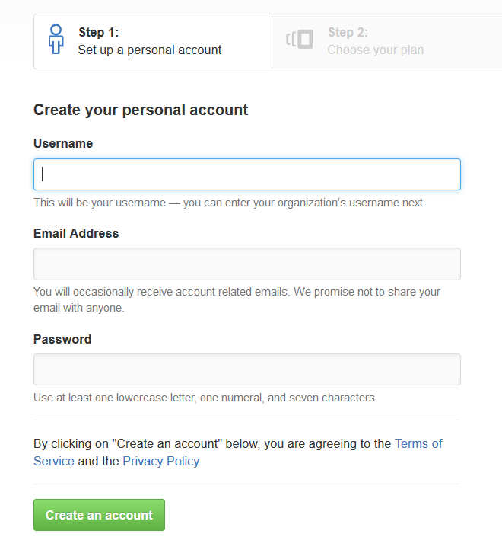

## Install GitHub Desktop Client Software

Download **GitHub Desktop** from: [https://desktop.github.com](https://desktop.github.com/). Follow the steps in the setup.

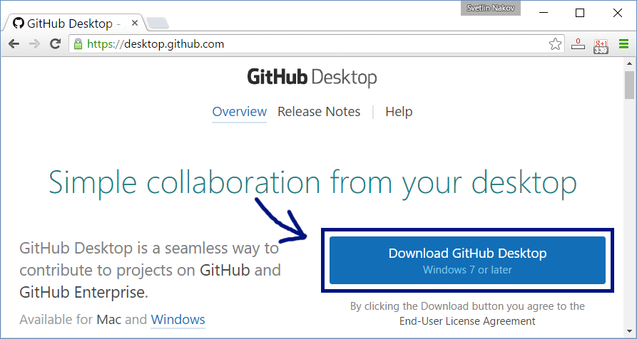

## Create and Clone a GitHub Repository

Work into **teams** of 5-10 students in class

* Online students work alone or form own teams.
* Each team selects a "**team leader**".

The team leader **creates a repository** in GitHub:

* New repository form: <https://github.com/new>.
* Choose a name for the repo, e.g. "test-repo".

The team leader needs to **add the other team members as collaborators** in the repository:

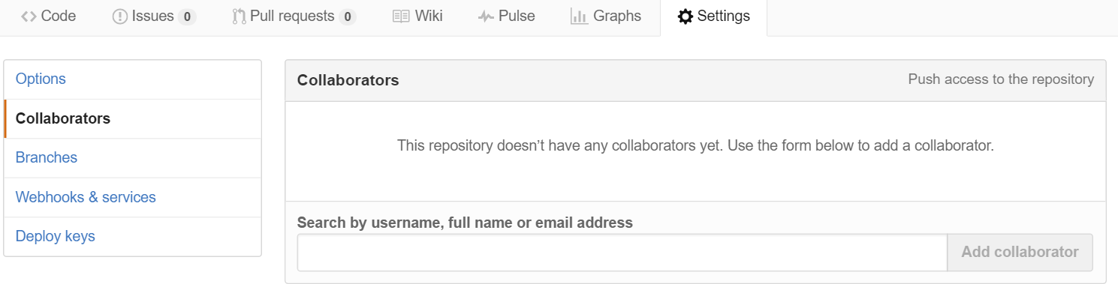

The other team members **clone the repository**:

* GitHub Desktop 🡪 Clone "**test-repo**".

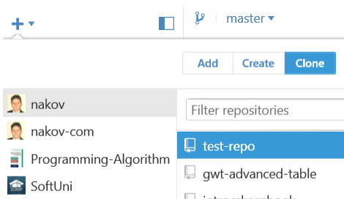

## Add a File to GitHub

Team members add a few files:

1. Clone the "test-repo" into your computer (if not cloned yet)
2. Create a new file into your working directory
   * Name the new file **<your_name>.txt**
   * Put some text in it the file, e.g. "*My name is …*"
3. Commit the **new file** to your **local repository**
4. Sync the changes to **upload your file to the remote repo**
5. Browse the repo from <https://github.com/user/repo> to check whether your file is successfully uploaded in GitHub.

## Create a Git Conflict & Merge

* All team members create a common file **config.txt**
* Each team member adds some settings in **config.txt**
  + E.g. *name = Peter*, *size = 100*, *email = peter@dir.bg*
* Each team member commits his local changes
* Each team member syncs his changes
  + The first will succeed without conflicts
  + The others will have a conflict to be merged
  + **Resolve** the conflict:
    - Edit the merged changes + commit and sync again

## Debug the Code: Non-Working Days between Two Dates

A program aims to count the non-working days between two dates (e.g. 1.05.2015 … 15.05.2015 🡪 5 non-working days). You can **find the broken code** in the judge system: <https://judge.softuni.bg/Contests/204/Git-GitHub-Debugging-Searching-Lab>. There are **4** **mistakes** in the code. You’ve got to **use the debugger** to find them and fix them. After you do that, submit your **fixed code in the judge contest**.

## Search in Google: Double Palindromes

The idea here is to **find** the numbers in **internet**, and to create a program that **only prints them**. Search in Google in order to find the first 129 double palindromes. Maybe the word “**double**” is **not the right** term.